Agenda Item : 2/02

= application site



11 Sherington Avenue, Pinner | P/0999/18

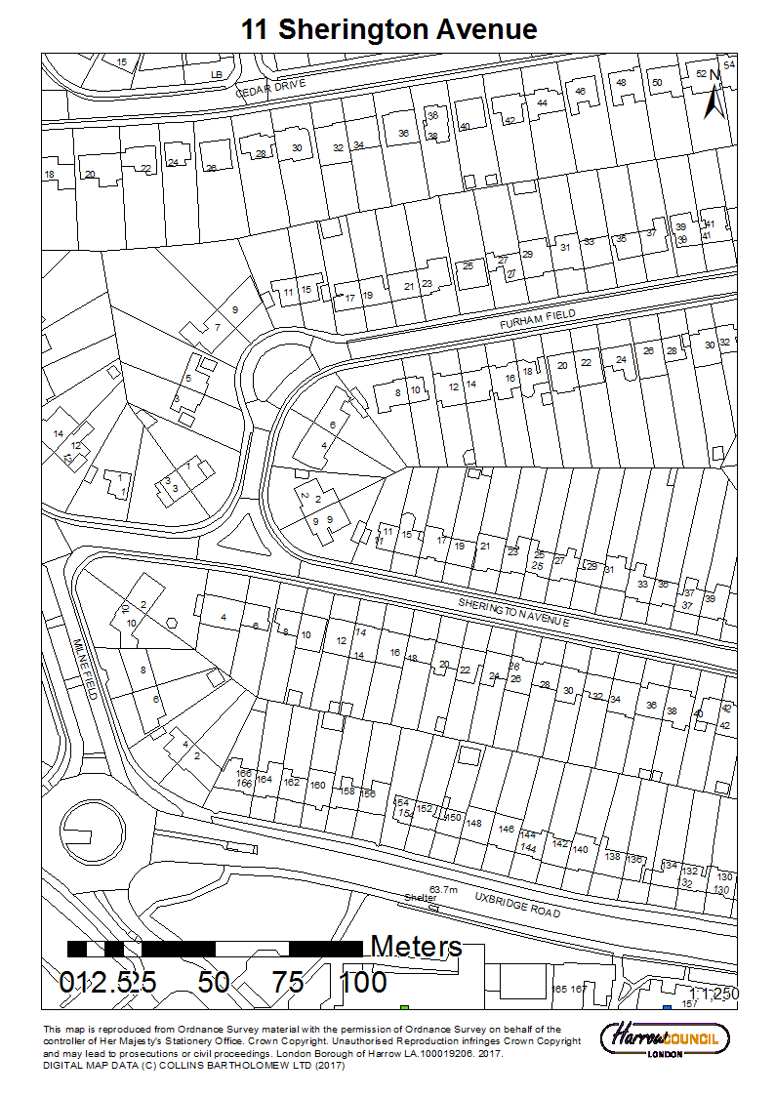

11 Sherington Avenue, Pinner | P/0999/18

LONDON BOROUGH OF HARROW

PLANNING COMMITTEE

30th May 2018

APPLICATION NUMBER: | P/0999/18
VALIDATE DATE: | 26/03/2018
LOCATION: | 11 SHERINGTON AVENUE, PINNER
WARD: | HATCH END
POSTCODE: | HA5 4DU
APPLICANT: | MR MOHAMED DEEN
AGENT: | N/A
CASE OFFICER: | KATIE PARKINS
EXPIRY DATE: | 06/04/2018
PURPOSE OF REPORT/PROPOSAL

The purpose of this report is to set out the Officer recommendations to the Planning Committee regarding an application for non-material amendment as follows:

Non-material amendment to planning permission P/5427/17 decision date 21/02/2018 to allow the addition of a rooflight on single storey rear extension.

The Planning Committee is asked to:

- agree the reasons for approval as set out in this report, and

- APPROVE the non-material amendment.

REASON FOR THE RECOMMENDATIONS

Within the context of the planning permission P/5427/17 granted permission on 21/02/2018, the proposed alterations and amendments identified in the above schedule would be non-material amendments. Accordingly, it is considered that the application for non-material amendments to the approved planning permission P/5427/17 should be approved.

INFORMATION

This application is reported to Planning Committee as the applicant is related to a member and therefore falls outside Part 1 (C.iii) of the Scheme of Delegation.

The Planning Committee granted planning permission subject to conditions (P/5427/17) on the 21st February 2018 for a: two storey side to rear extension; single storey rear extension; rear dormer; two rooflights to the front roofslope to create habitable roofspace (demolition of existing garage).

Statutory Return Type: | 21 Householder
Council Interest: | None
GLA Community Infrastructure Levy (CIL) Contribution (provisional): | Not applicable  Not applicable  Not applicable
Local CIL requirement: | Not applicable
HUMAN RIGHTS ACT

The provisions of the Human Rights Act 1998 have been taken into account in the processing of the application and the preparation of this report.

EQUALITIES

In determining this planning application the Council has regard to its equalities obligations including its obligations under section 149 of the Equality Act 2010.

For the purposes of this application there are no adverse equalities issues.

S17 CRIME & DISORDER ACT

Policies 7.3.B and 7.13.B of The London Plan and Policy DM1 of the Development Management Polices Local Plan require all new developments to have regard to safety and the measures to reduce crime in the design of development proposal. It is considered that the development does not adversely affect crime risk.

LOCAL GOVERNMENT (ACCESS TO INFORMATION) ACT 1985
BACKGROUND PAPERS USED IN PREPARING THIS REPORT:

- Planning Application
- Statutory Register of Planning Decisions
- Correspondence with Adjoining Occupiers
- Correspondence with Statutory Bodies
- Correspondence with other Council Departments
- National Planning Policy Framework
- London Plan
- Local Plan - Core Strategy, Development Management Policies, SPGs
- Other relevant guidance

LIST OF ENCLOSURES / APPENDICES:

Officer Report:
Part 1: Planning Application Fact Sheet
Part 2: Officer Assessment
Appendix 1 – Site Plan
Appendix 2 – Site Photographs
Appendix 3– Plans and Elevations

OFFICER REPORT

PART 1: Planning Application Fact Sheet

The Site

Address | 11 Sherington Avenue, Pinner, HA5 4DU
Applicant | Mr Shaharan Deen
Ward | Hatch End
Local Plan allocation | No
Conservation Area | No
Listed Building | No
Setting of Listed Building | No
Building of Local Interest | No
Tree Preservation Order | No
Other | Critical Drainage Area.

PART 2: Assessment

- SITE DESCRIPTION

  - The application property is No 11 Sherington Avenue, a two-storey semi-detached dwellinghouse. The site has a prominent position within the streetscene due to its location on the corner of Sherington Avenue and Furham Feild. The application site has a staggered building line with the neighbouring property No.9 Furham Feild, and as such there are direct views of the flank wall of the host dwelling.

  - The adjoining property, No.15 Sherington Avenue has been previously extended by a single storey rear extension with a depth of approximately 3.3m and a rear dormer.

- PROPOSAL

  - Planning permission was granted for a two storey side to rear extension, rear dormer, two rooflights to front roofslope to create habitable roofspace (demolition of existing garage).

  - The applicant has applied for a non-material amendment to insert a rooflight in the approved single storey rear extension. The rooflight would be 2m x 1m and would have a maximum upstand of 150mm above the plane of the roof.

- RELEVANT PLANNING HISTORY

  - A summary of the relevant planning application history is set out in the table below:

Ref no. | Description | Status and date of decision
P/5427/17 | Two storey side to rear extension; single storey rear extension; rear dormer; two rooflights to the front roofslope to create habitable roofspace (demolition of existing garage). | Granted  21st February 2018

- CONSULTATION

  - As an application under Section 96A of the Town and country Planning Act 1990 is not an application for planning permission, the existing provisions under the Town and Country (General Development Procedure) Order 2015 (as amended) in respect of planning applications do not apply. No consultation has therefore been undertaken as part of this application.
- POLICIES

5.1 Section 38(6) of the Planning and Compulsory Purchase Act 2004 requires that:

‘If regard is to be had to the Development Plan for the purpose of any determination to be made under the Planning Acts, the determination must be made in accordance with the Plan unless material considerations indicate otherwise.’

5.2 In this instance, the Development Plan comprises The London Plan 2016, The Harrow Core Strategy 2012 [CS], Harrow and Wealdstone Area Action Plan (AAP) 2013, the Development Management Policies Local Plan 2013 [DMP], the Site Allocations Local Plan SALP 2013 [SALP].

5.3 While this application has been principally considered against the adopted London Plan (2016) policies, some regard has also been given to relevant policies in the Draft London Plan (2017), as this will eventually replace the current London Plan (2016) when adopted and forms part of the development plan for the Borough.

5.4 The document has been published in draft form in December 2017. Currently, the Mayor of London is seeking representations from interested parties/stakeholders, before the draft Plan is sent to the Secretary of State for Examination in Public, which is not expected to take place until the summer of 2019. Given that that the draft Plan is still in the initial stages of the formal process it holds very limited weight in the determination of planning applications.

5.5 Notwithstanding the above, the Draft London Plan (2017) remains a material planning consideration, with relevant polices referenced within the report below and a summary within Informative 1.

6.0 ASSESSMENT

6.1 The main issues are;
  - Materiality

  - Materiality

    - In this instance, the applicant seeks to make alterations to the granted development under planning application reference P/1759/17. The question in this instance is whether the alterations proposed would have a material impact on the development. Departmental guidance advises that there is no statutory definition of ‘non-material’. This is because it is so dependent on the context of the overall scheme – what may be non-material in one context may be material in another. For a change to be material, it is considered that it must be of significance, of substance and of consequence

    - The proposed amendment to insert a rooflight in the single storey rear extension would not alter the overall appearance of the proposed extension nor result in a detrimental impact to the residential amenities of neighbouring properties. It is therefore considered that the proposed alterations would not substantially alter the approved development granted under planning permission P/1759/17 within the overall context of the development.

    - Accordingly, it is considered that the proposed alteration would not materially alter the original development that was granted planning permission.

7.0 CONCLUSION AND REASONS FOR APPROVAL

7.1 Within the context of the planning permission P/5427/17 granted permission on 21/02/2018, the proposed alterations and amendments identified in the above schedule would be non-material amendments. Accordingly, it is considered that the application for non-material amendments to the approved planning permission P/5427/17 should be approved.

Plan Nos: B-05 Rev:B, B-01 Rev:A, 1:500 Block Plan, 1:1250 Location Plan

APPENDIX 1: SITE PLAN

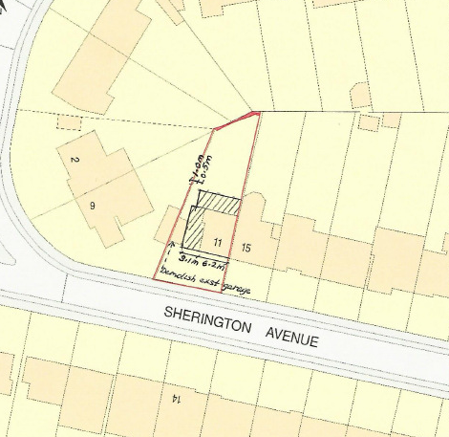

APPENDIX 2: SITE PHOTOGRAPHS

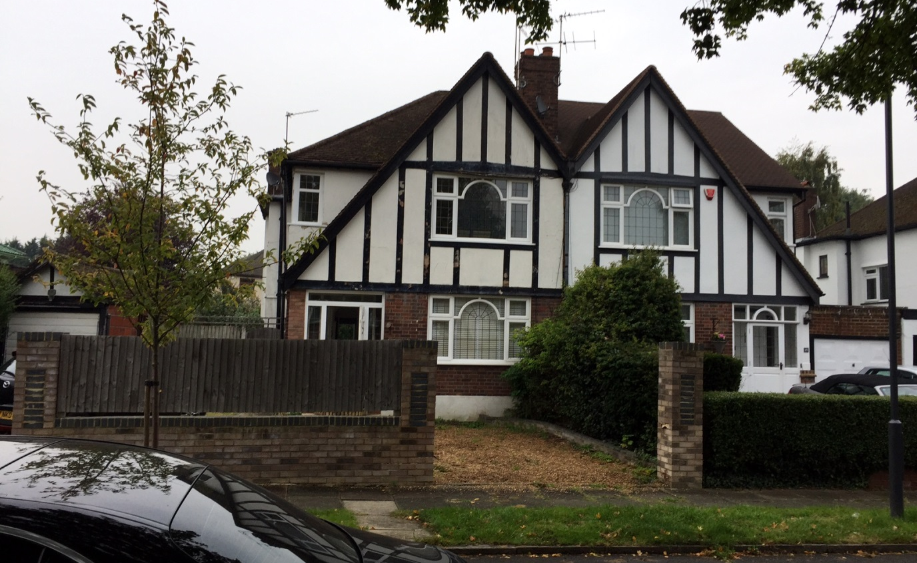

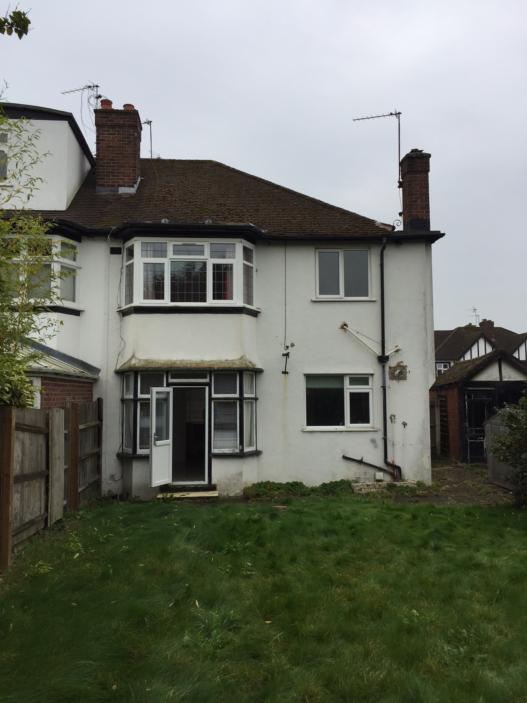

Rear elevation of 11 Sherington Avenue

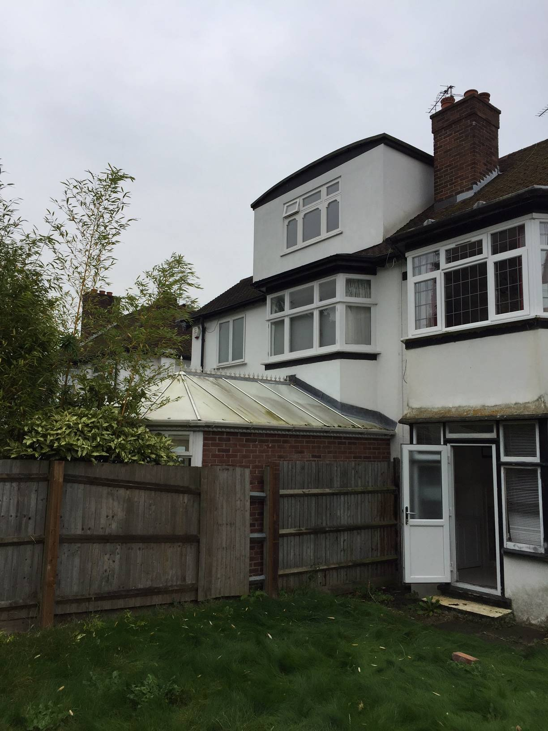
Rear elevation of the adjoining property No.15 Sherington Avenue

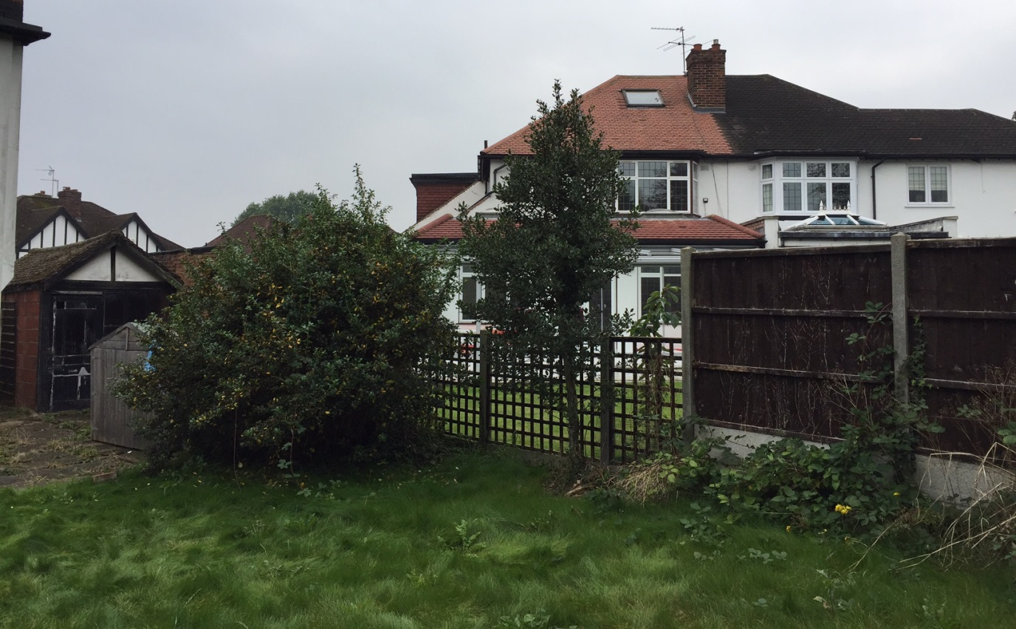

Rear elevation of neighbouring properties No.9 Sherington Avenue and the adjoining property No.2 Furham Feild.

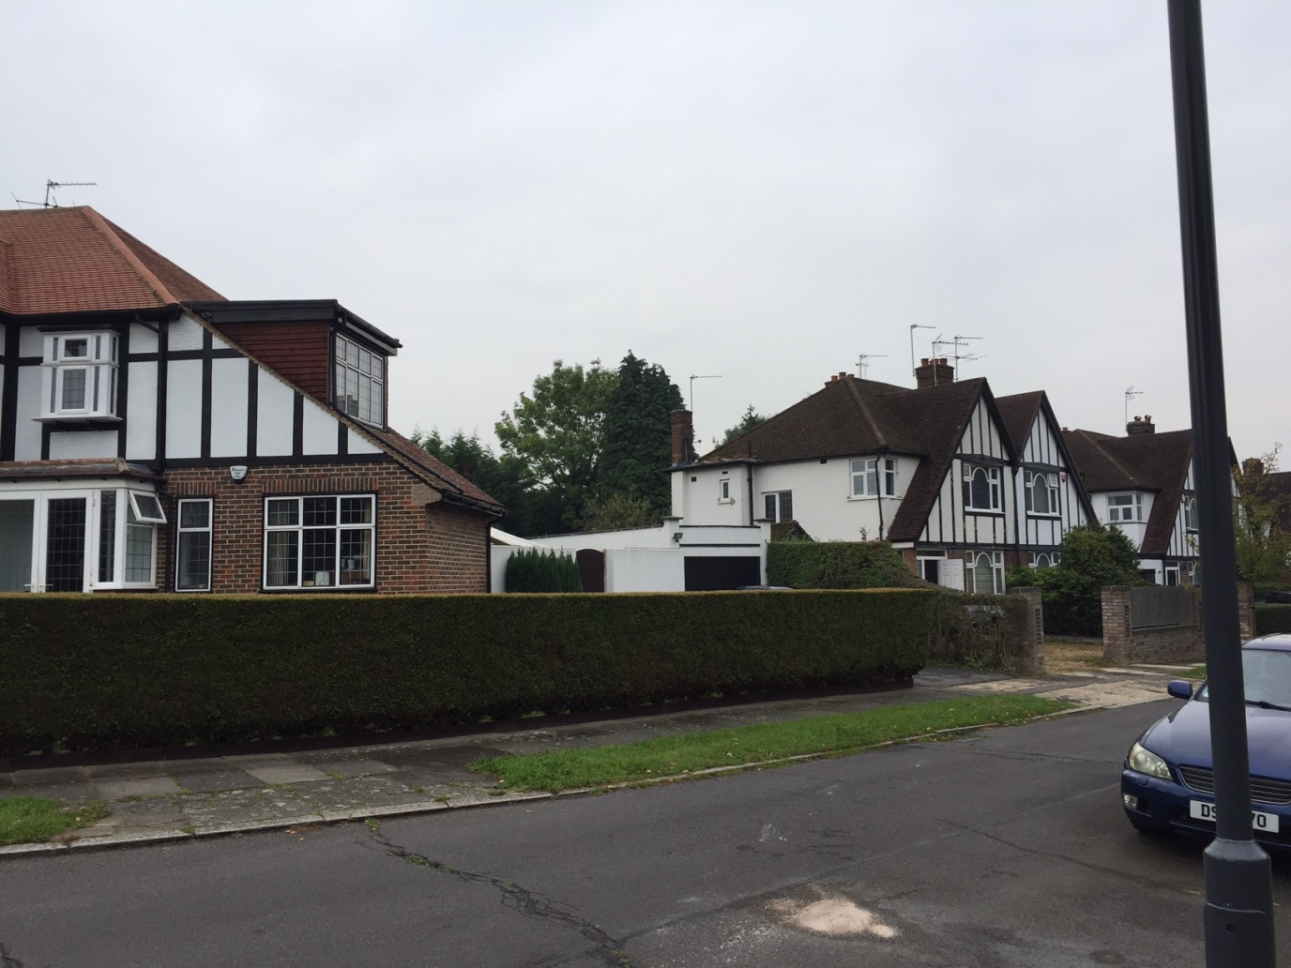

Front/side elevation of host dwelling when viewed from Furham Feild
APPENDIX 3: PLANS AND ELEVATIONS

Proposed Elevations

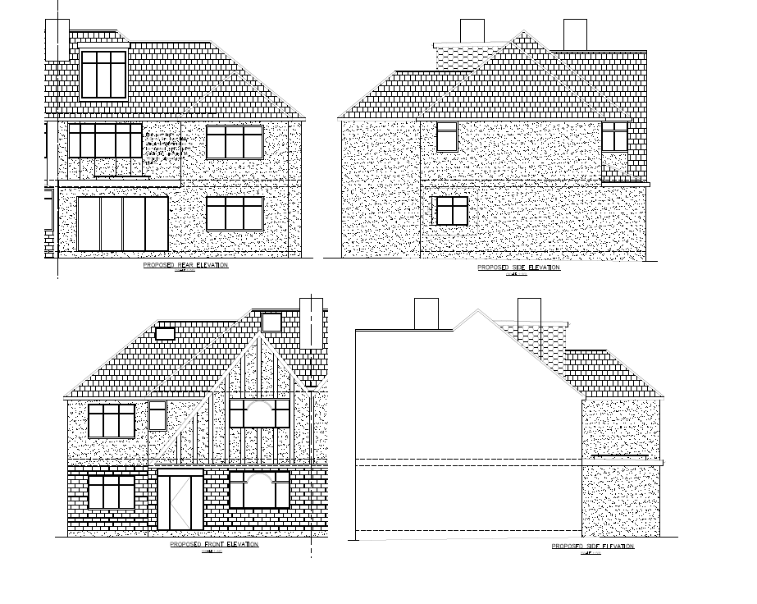

Proposed Floorplans

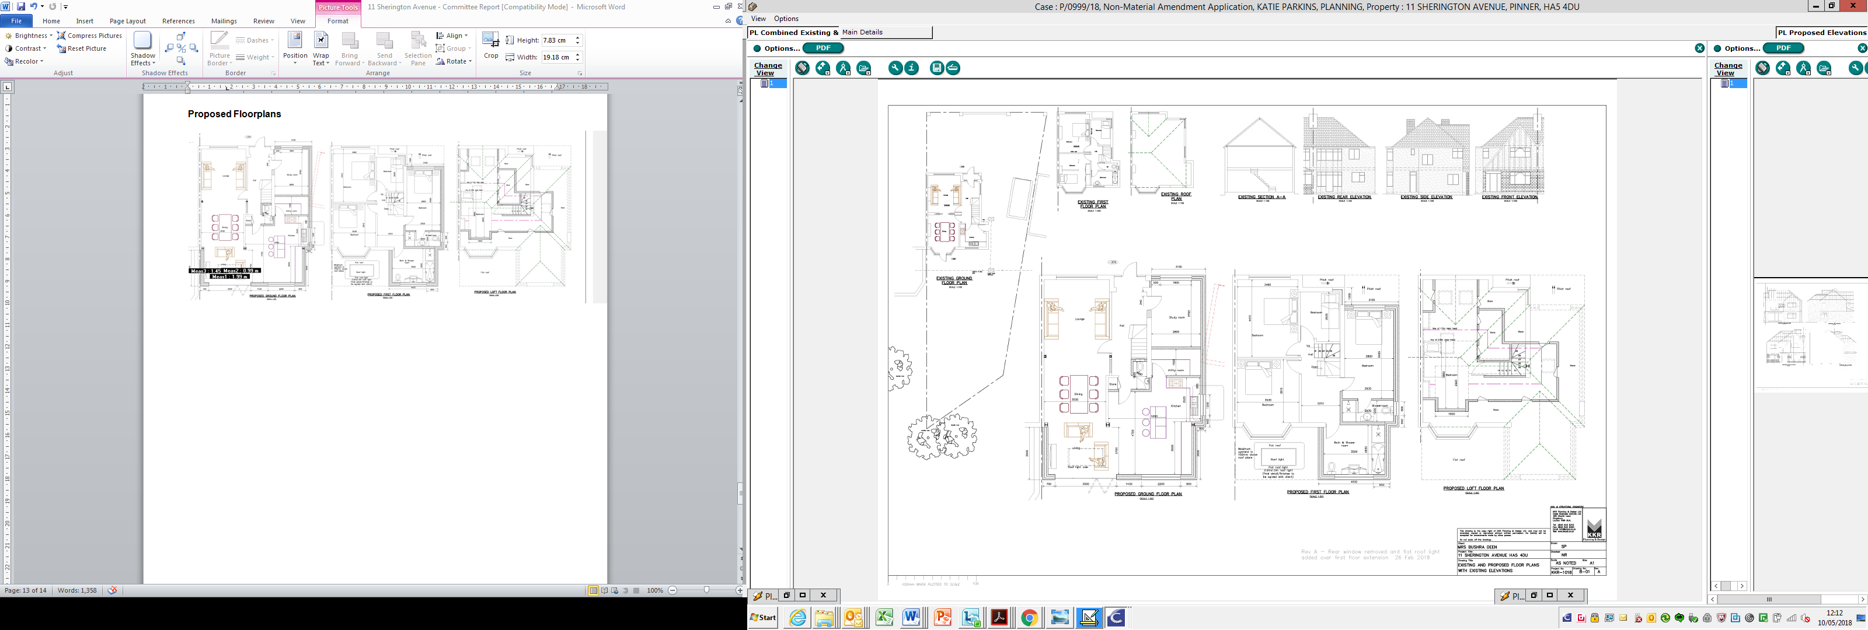

This page has been left intentionally blank

